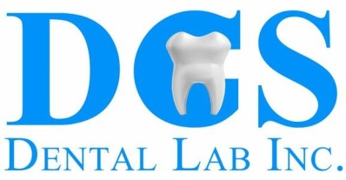

DCS Dental Lab accepts digital impression files from most major intraoral scanners. Follow the below steps associated with your ios scanner to submit your next digital case:

3M True Definition
- Log into your 3M Portal
- Search for us by typing “DCS Dental Lab” and then select our lab
- Once you are connected to our lab, select “DCS Dental Lab” on your scanner when sending files

Carestream
- Due to the open architecture of Carestream Systems, your digital impression can be sent directly to our lab
- Save your digital impression files as “.stl” files, and use Dropbox to submit your case digitally
  - Our Dropbox email is: dcsteam@dcslab.com

Itero®
- Call Itero customer support at (800) 577-8767 and select option 1
- Request that DCS Dental Lab is added to your “Preferred Lab” list and identify our lab using our phone number (904) 448-0011 or our lab ID #2091
- After our lab has been added, restart your scanner
- Once you are connected to our lab, select “DCS Dental Lab” on your scanner when sending files

Medit
- Create an account on Medit and follow the prompts for activating an account
- Select “Administrator” under the clinic tab
- After creating your account, you will receive a verification email with download instructions
- Once the download is complete, click “Add New Partner” and search for “DCS Dental Lab” to begin sending cases to our lab

Planmeca PlanScan
- To export models in STL format, click the case in the patient’s list of case files and click “3D Model Export”.
- Navigate to the desired destination folder, save your digital impression files as “.stl” files, and use Dropbox to submit your case digitally
  - Our Dropbox email is: dcsteam@dcslab.com

Sirona CEREC
- Log into your account on Sirona Connect
- On left margin under My Partner, select “my favorite contractor”
- Search for us by typing “DCS Dental Lab” or our lab's zip code (32217)
- Check the box to the bottom left for “DCS Dental Lab” and click “Add” to complete the registration
- Once you are connected to our lab, select “DCS Dental Lab” on your scanner when sending files

Trios
- Log into your 3shape Communicate Portal
- Open the “Connections” section at the top of the page
- On the top left of the page, click “Add Connection”
- Search for DCS Dental Lab by typing our lab's email (dory@dcslab.com), and then select our lab
- After your connection is approved from our lab, select “DCS Dental Lab” on your scanner when sending files

If you have any questions, please don’t hesitate to call us at (904) 448-0011. Thank you!

