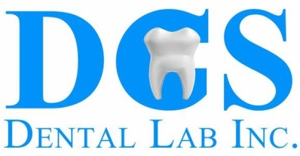

For exceptional clinical results, please follow this checklist for any cases with 4 or more units:
- Pre Op Impression or Diagnostic Wax Up
- Impression/model of patient approved temporaries
- Pre Op pictures (smiling, relaxed, etc.)
- Pre Op bite registration
- Specify goals of case (lengthen, straighten, etc.)
- Full arch PVS impressions
- Post Op bite registration
- Facebow (optional)
- Schedule custom staining with lab if needed - (904) 448-0011

